NAME:Ritika Kher

MIS:112103116

Div: 2

Batch:S2

ASSIGNMENT:SHELL SCRIPTING

1)To view a single file:

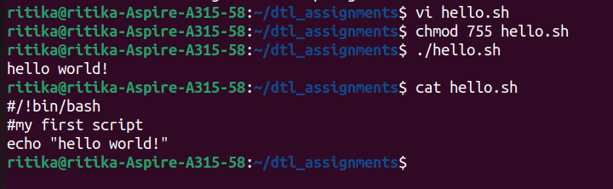

2)To view multiple files:

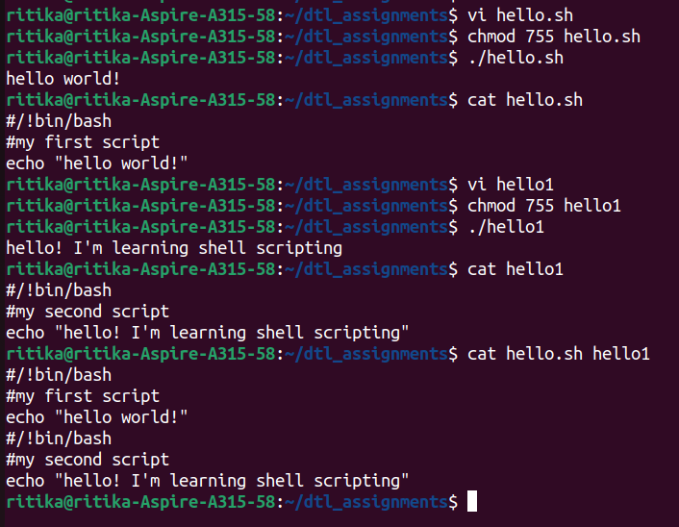

3)To view the contents of a file preceding with line numbers:

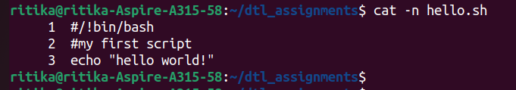

4)To create a file:

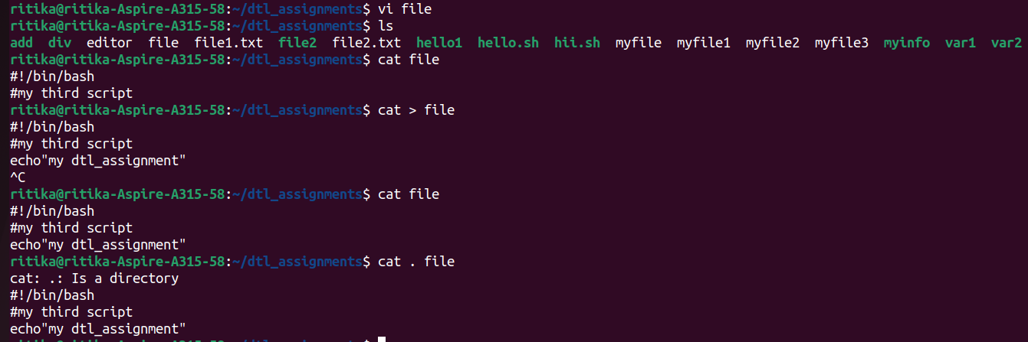

5)Copy the contents of one file to another file:

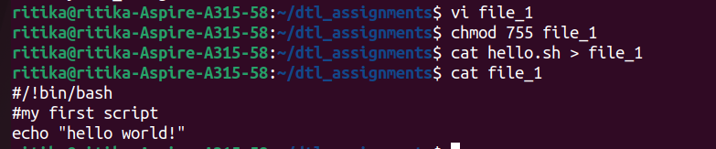

6)cat command can suppress repeated empty lines in output:

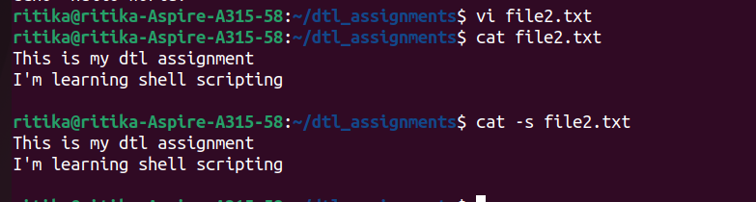

7)Cat command can append the contents of one file to the end of another file:

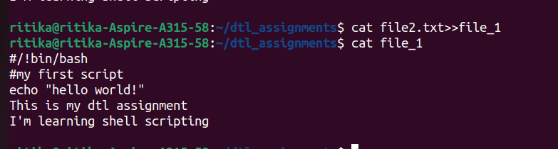

8)cat command can display content in reverse order using tac command:

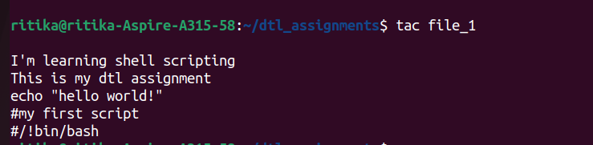

9)cat command can highlight the end of the line:

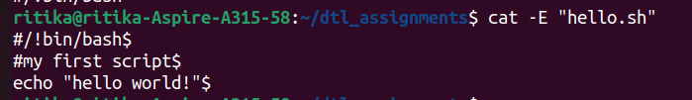

10)If you want to use the -v, -E and -T option together, then instead of writing -vET in the command, you can use the -A command line option:

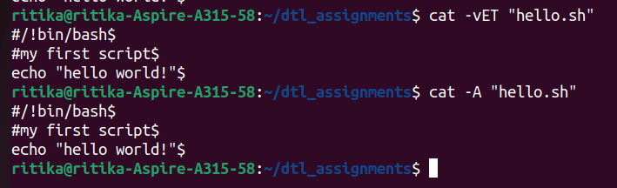

11)cat command to open dashed files:

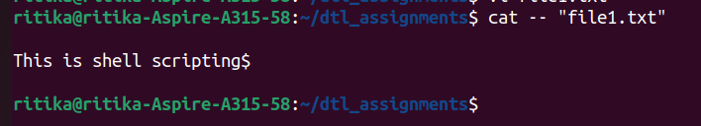

12)cat command if the file has a lot of content and can’t fit in the terminal:

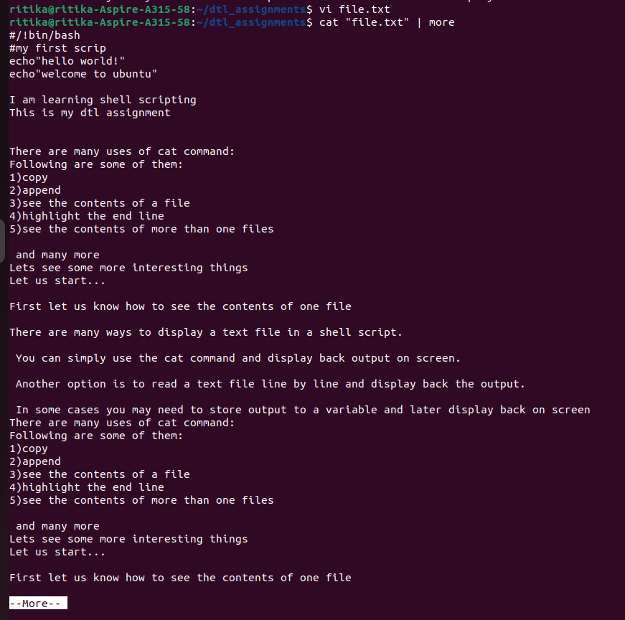

13)cat command to merge the contents of multiple lines:

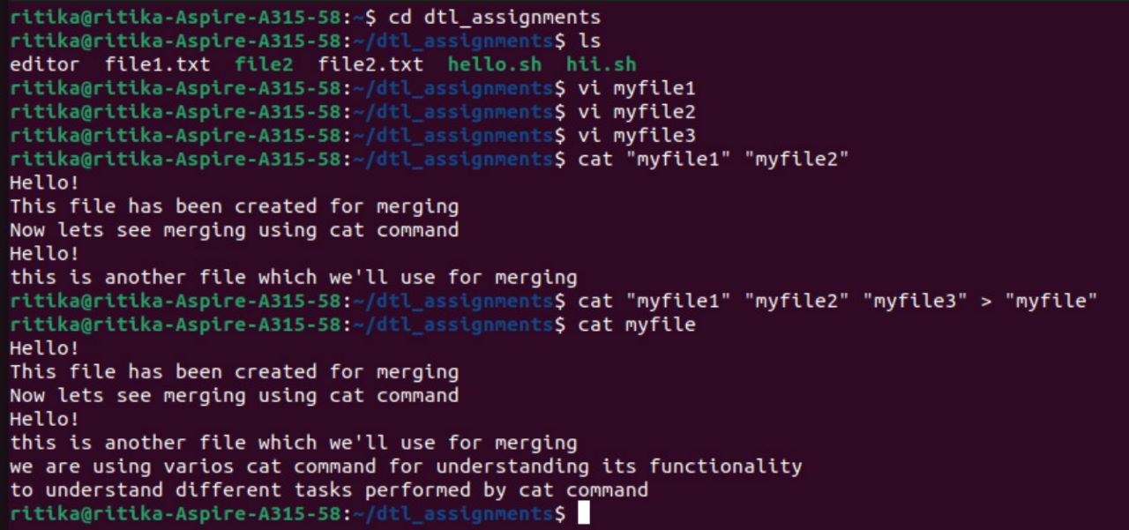

14)cat command to display the content of all text files in the folder:

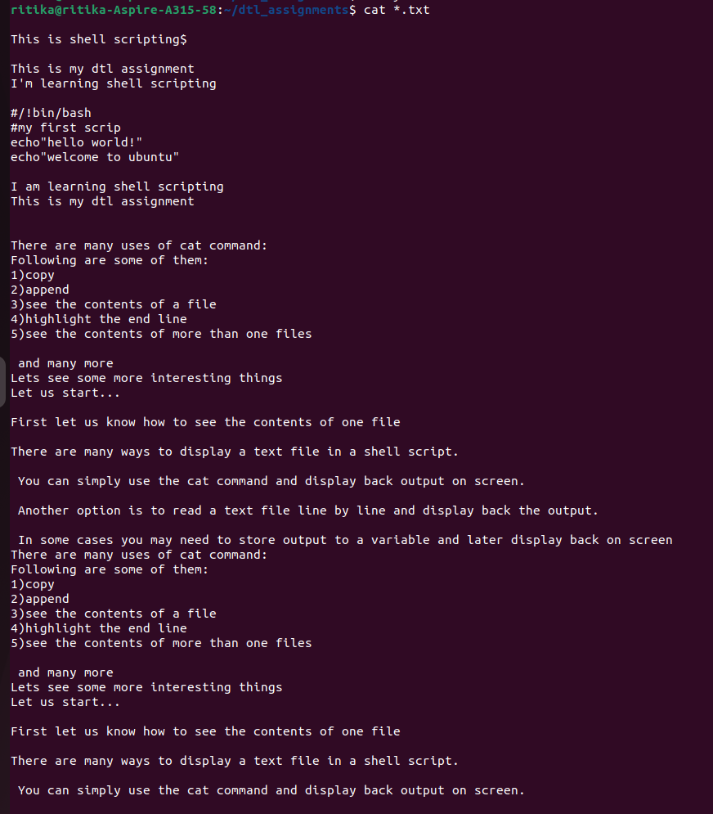

15)cat command to write in an already existing file:

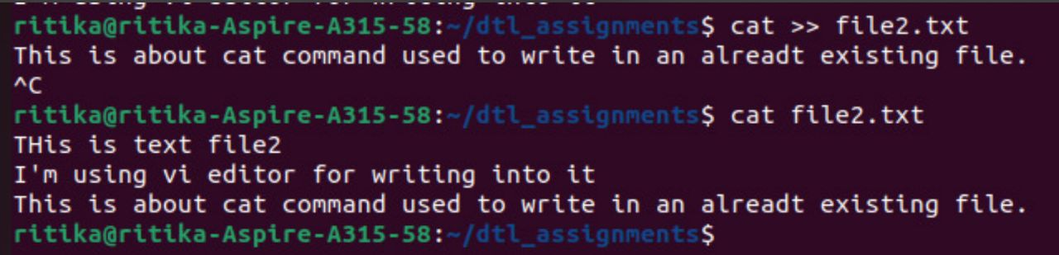

16) How to define variable x with value 10 and print it on screen.

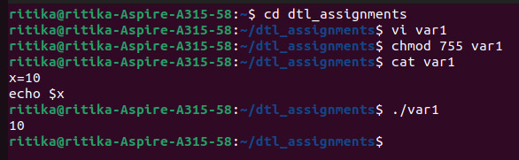

17) How to define variable xn with value Rani ad print it on screen.

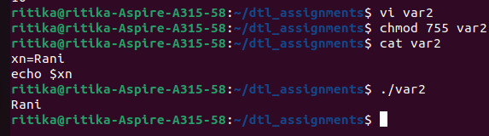

18) How to print sum of two numbers, let’s say 6 and 3.

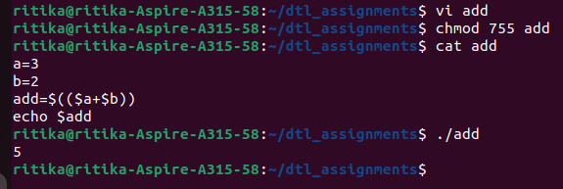

19) How to define two variables x=20, y=5 and then to print division of x and y (i.e x/y).

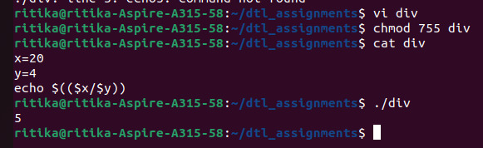

20) Modify above and store division of x and y to variable called z.



21) Write a script to read your name, class, div etc. information from keyboard.

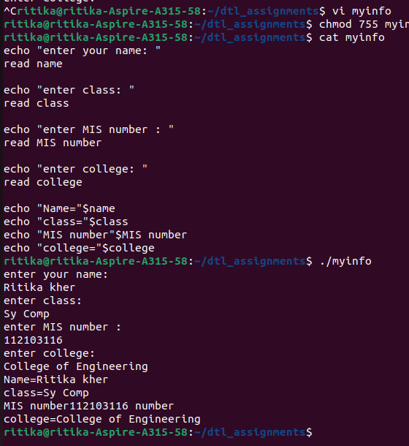

22) Write commands to show the use of “ ”.

